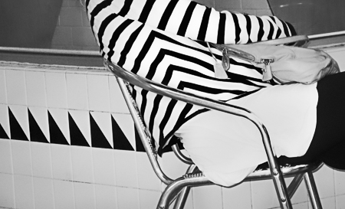
“The Child Bent Becomes the Bender” by Jody Levinson
The Collection of Photographer Jody Levinson

Best Impressions
Photography Exhibit
Featuring:
Trigger Aoki, Janet Cass, Darlene, Gregg Felsen, Colin Fisher,
Jody Levinson & Kenneth McGowan,
October 21st through November 3, 2017

Colin Fisher Studios
68929 Perez Road, Suite M Cathedral City, CA 92234
(760) 324-7300, Email: colin@colinfisher.com or
michael@colinfisherstudios.com
Jody Levinson

Jody is a life-long artist. She attended the School of the Museum of Fine Arts (formerly the Boston Museum School) at Tufts University, where she received her BFA with a major in sculpture and drawing. Jody has also completed advanced studies at Moore College of Art and the Pennsylvania Academy of Fine Arts, both in Philadelphia. As an adjunct to her work, she has been a gallerist and instructor. Her work has principally focused on figures, landscapes, still life and abstract work. While continuing to work on hand-built ceramic sculpture and a body of humorist illustrations, which are about to be published, Jody began studying photography in 2008 at the International Center for Photography, Maine Media College and Anderson Ranch Arts Center. Today, photography is Jody’s principal artistic passion.

Artist Statement

Looking at the obvious, the usual and mundane, I work to find specific design elements living inside larger, ordinary objects. I may find these wonderful surprises anywhere . . . . in an alley, a door frame or corner of a tent. I watch and wait for the elements to show themselves. . . . silently waiting to be found. I imagine them to be joyful when found, or perhaps it is my joy that is found when I spot the shapes, light, texture, balance and gesture that make my heart sing.
Jody Levinson

Jody Levinson
“The Child Bent Becomes the Bender”
Printed on the highest quality Canson Baryta Photographique
310g/m2 with archival inks on an Epson P9000, Edition of 20
24” x 36” = $1,200
Pricing reflects the cost for an unframed print
Framing and other print sizes are available upon request.
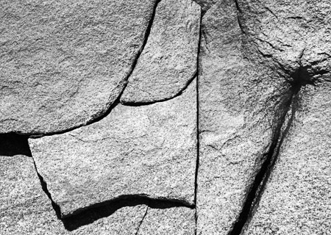
Jody Levinson
“DJT”
Printed on the highest quality Canson Baryta Photographique
310g/m2 with archival inks on an Epson P9000, Edition of 20
24” x 36” = $1,200
Pricing reflects the cost for an unframed print
Framing and other print sizes are available upon request.

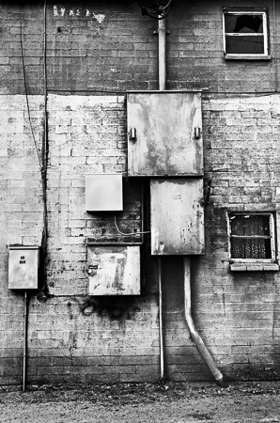
Jody Levinson
“Flapper”
Printed on the highest quality Canson Baryta Photographique
310g/m2 with archival inks on an Epson P9000, Edition of 20
24” x 36” = $1,200
Pricing reflects the cost for an unframed print
Framing and other print sizes are available upon request.

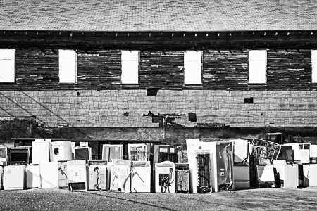
Jody Levinson
“Little Household Gods Upon Their Altar”
Printed on the highest quality Canson Baryta Photographique
310g/m2 with archival inks on an Epson P9000, Edition of 20
24” x 36” = $1,200
Pricing reflects the cost for an unframed print
Framing and other print sizes are available upon request.

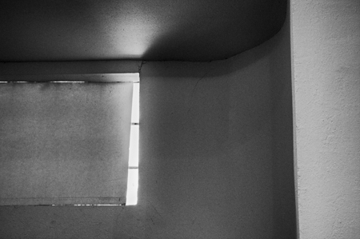
Jody Levinson
“If You Want to Make Me Cry”
Printed on the highest quality Canson Baryta Photographique
310g/m2 with archival inks on an Epson P9000, Edition of 20
24” x 36” = $1,200
Pricing reflects the cost for an unframed print
Framing and other print sizes are available upon request.

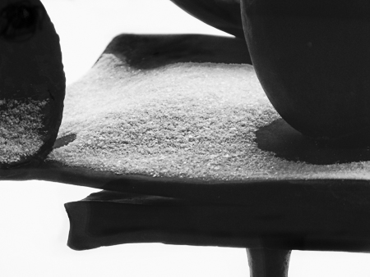
Jody Levinson
“Service Please”
Printed on the highest quality Canson Baryta Photographique
310g/m2 with archival inks on an Epson P9000, Edition of 20
24” x 36” = $1,200
Pricing reflects the cost for an unframed print
Framing and other print sizes are available upon request.

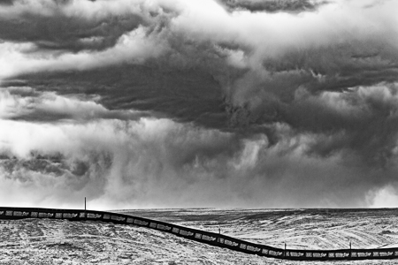
Jody Levinson
“Goodness Gracious”
Printed on the highest quality Canson Baryta Photographique
310g/m2 with archival inks on an Epson P9000, Edition of 20
24” x 36” = $1,200
Pricing reflects the cost for an unframed print
Framing and other print sizes are available upon request.

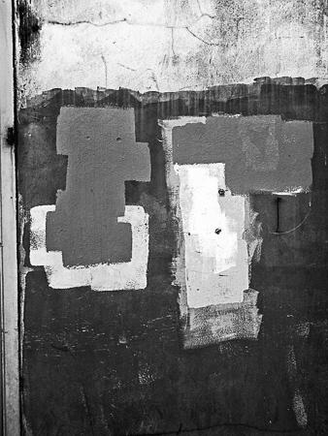
Jody Levinson
“In Your Renouncing, Is It Truly There?”
Printed on the highest quality Canson Baryta Photographique
310g/m2 with archival inks on an Epson P9000, Edition of 20
24” x 36” = $1,200
Pricing reflects the cost for an unframed print
Framing and other print sizes are available upon request.

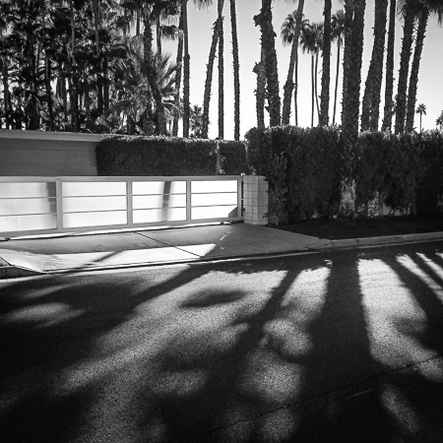
Jody Levinson
“I Hear You Knocking, but…..”
Printed on the highest quality Canson Baryta Photographique
310g/m2 with archival inks on an Epson P9000, Edition of 20
24” x 36” = $1,200
Pricing reflects the cost for an unframed print
Framing and other print sizes are available upon request.

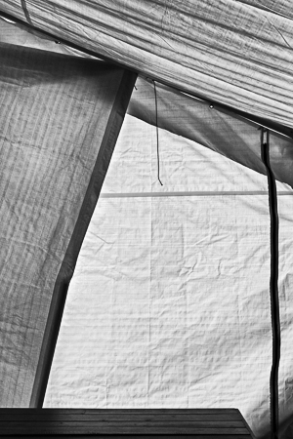
Jody Levinson
“Tie Me Down”
Printed on the highest quality Canson Baryta Photographique
310g/m2 with archival inks on an Epson P9000, Edition of 20
24” x 36” = $1,200
Pricing reflects the cost for an unframed print
Framing and other print sizes are available upon request.

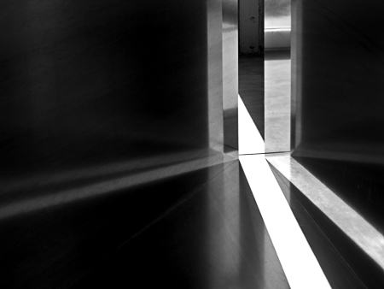
Jody Levinson
“Judd”
Printed on the highest quality Canson Baryta Photographique
310g/m2 with archival inks on an Epson P9000, Edition of 20
24” x 36” = $1,200
Pricing reflects the cost for an unframed print
Framing and other print sizes are available upon request.

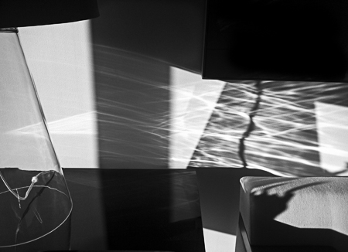
Jody Levinson
“M.E.’s Pool”
Printed on the highest quality Canson Baryta Photographique
310g/m2 with archival inks on an Epson P9000, Edition of 20
24” x 36” = $1,200
Pricing reflects the cost for an unframed print
Framing and other print sizes are available upon request.

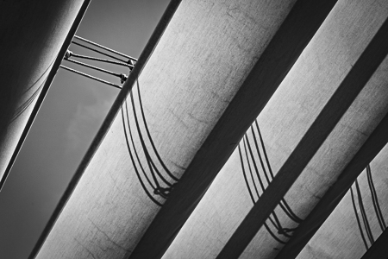
Jody Levinson
“Chasm Between Two (Part 1)”
Printed on the highest quality Canson Baryta Photographique
310g/m2 with archival inks on an Epson P9000, Edition of 20
24” x 36” = $1,200
Pricing reflects the cost for an unframed print
Framing and other print sizes are available upon request.

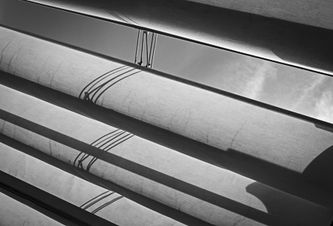
Jody Levinson
“Chasm Between Two (Part 2)”
Printed on the highest quality Canson Baryta Photographique
310g/m2 with archival inks on an Epson P9000, Edition of 20
24” x 36” = $1,200
Pricing reflects the cost for an unframed print
Framing and other print sizes are available upon request.

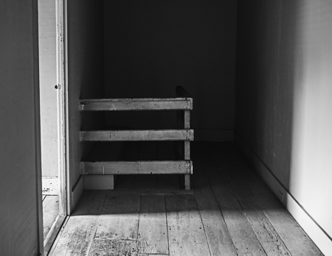
Jody Levinson
“Olsons Crib”
Printed on the highest quality Canson Baryta Photographique
310g/m2 with archival inks on an Epson P9000, Edition of 20
24” x 36” = $1,200
Pricing reflects the cost for an unframed print
Framing and other print sizes are available upon request.

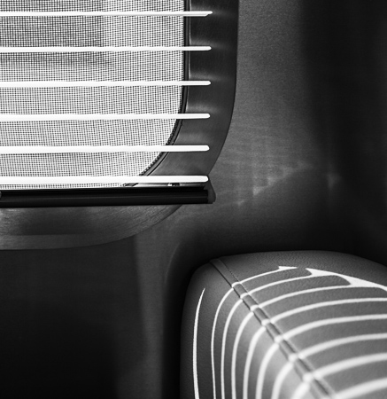
Jody Levinson
“Airstream”
Printed on the highest quality Canson Baryta Photographique
310g/m2 with archival inks on an Epson P9000, Edition of 20
24” x 36” = $1,200
Pricing reflects the cost for an unframed print
Framing and other print sizes are available upon request.

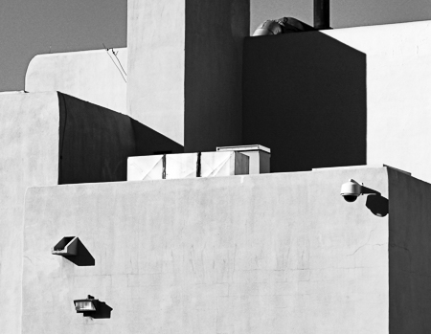
Jody Levinson
“BBB”
Printed on the highest quality Canson Baryta Photographique
310g/m2 with archival inks on an Epson P9000, Edition of 20
24” x 36” = $1,200
Pricing reflects the cost for an unframed print
Framing and other print sizes are available upon request.

